**Design:**

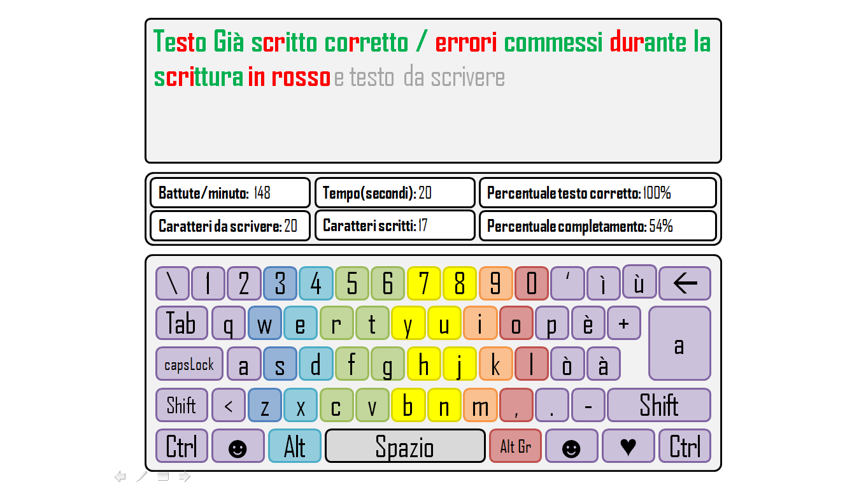

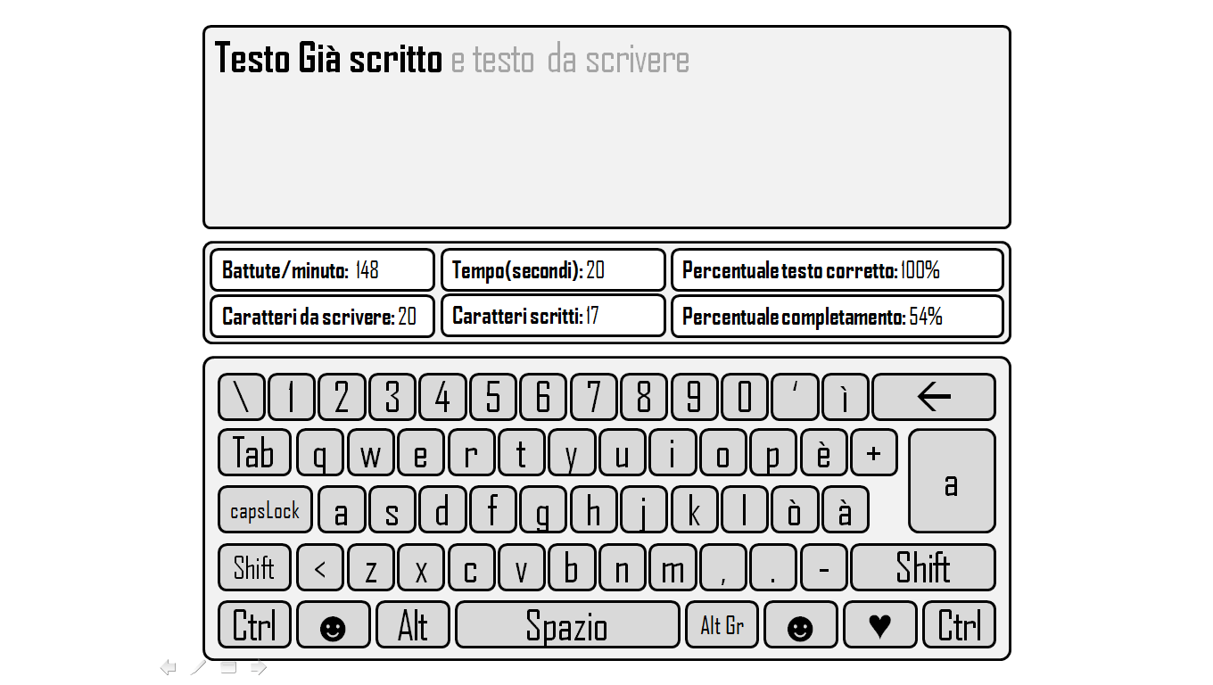

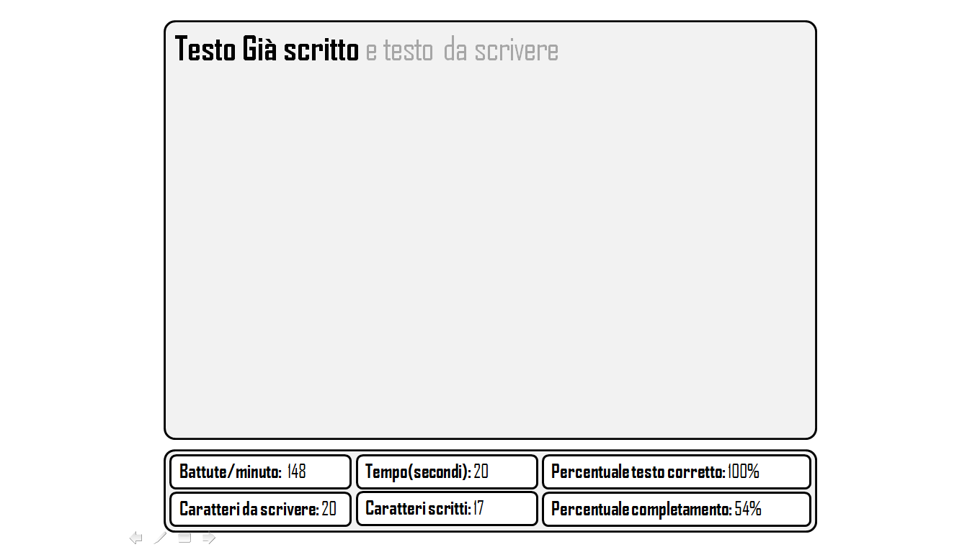

**Behavior:**

The first picture represents exercise page in “easy mode”, the second one in “medium mode”, and the third one in “hard mode”. The text which has already been written Becomes **Coloured** (green correct parts/red mistakes) or **black**, else it is light grey. In the bar in the middle there will be some counters as beats per minute, percentage of mistakes etc… At the end of the exercise the data will be saved in the “current user”, so that you can see your progress and you improvements! During the exercise the data will be update constantly. Every counter is an instantiation of “Box”.